


REPORT
Punjab Mediation Center Study Visit
19th November-22nd November 2019
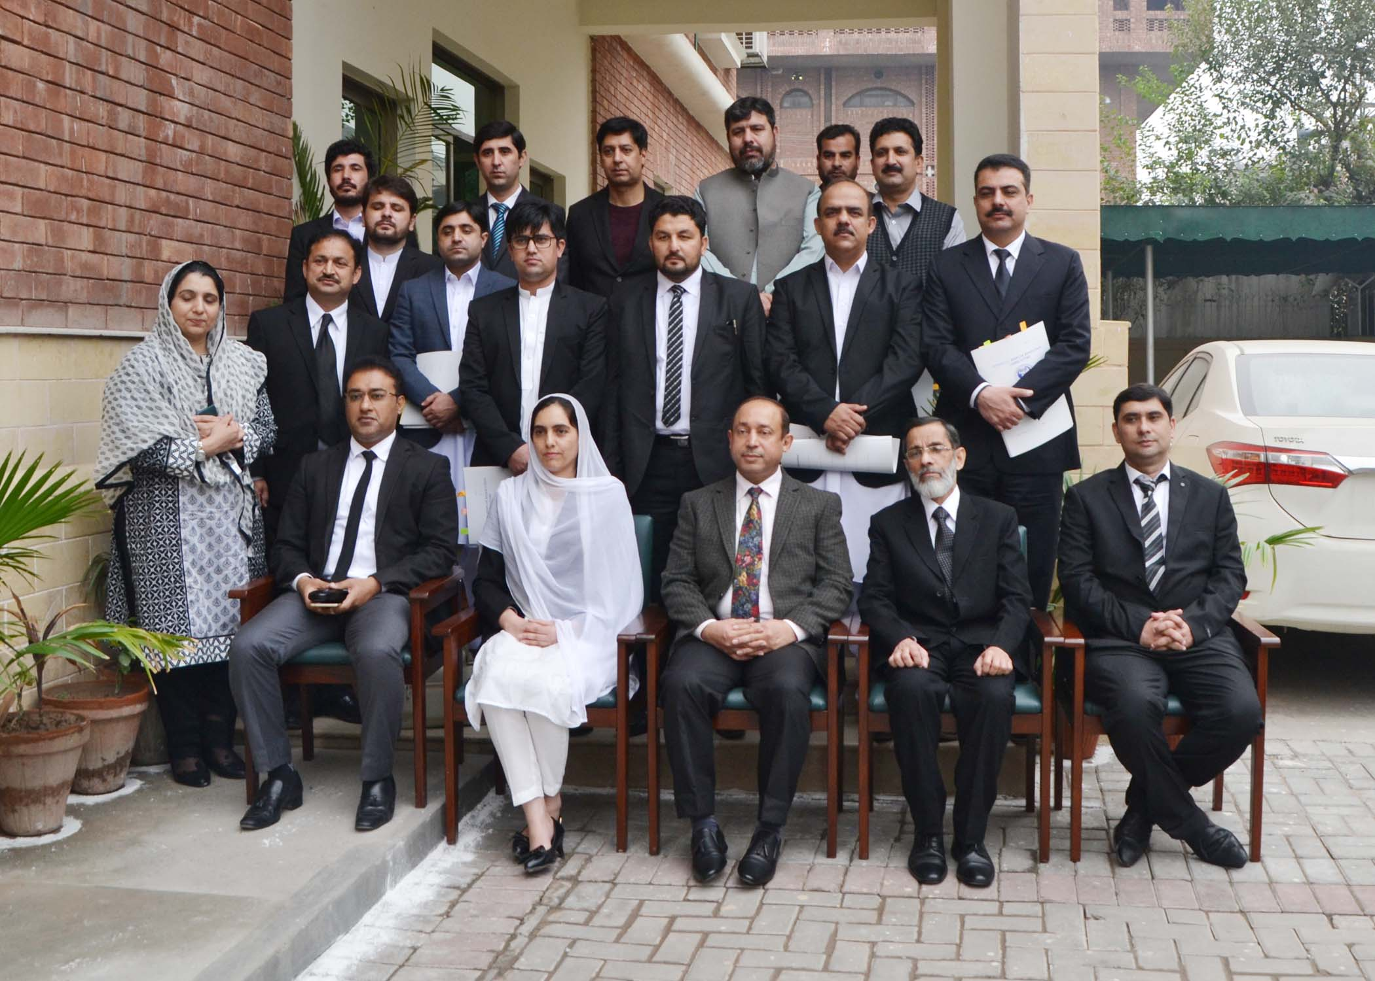
______________________________________________________________________________Khyber Pakhtunkhwa Judicial Academy, Old Sessions Court Building, Jail Road, Peshawar
info@kpja.edu.pk | www.kpja.edu.pk
Table of Contents
1.0 Introduction 3
2.0 Concept Paper 3
3.0 Day 1 6
4.0 Day 2 7
5.0 Conclusions and Recommendations 8
6.0 Participants 9
7.0 Study Visit in Pictorial 10

1.0 Introduction

1.1 KPJA is statutorily mandated to provide training to all justice sector stakeholders, to hold conferences, seminars, lectures, workshops and symposia in matters relating to court management, administration of justice, law and development of skills in legislative drafting and to establish liaison with research institutions, universities and other bodies including the Federal Judicial Academy, towards the cause of administration of justice. (Section 4 of the Academy Act)
1.2 Honourable Peshawar High Court, vide order contained in endorsement # SDJ / PHC / REG/64-V.II.1301-6 of 21.03.019, was pleased to set up a committee to frame rules under section 89-A CPC. The Committee framed the rules that are now pending consideration before the Honourable High Court. The rules are intended to meet the gap for elaborate mechanisms of alternative dispute resolution mechanisms and also visualize the creation of mediation centers. The judicial officers will be the mediators according to the rules- hence the concept of declaring KPJA as the mediation school of learning with the provision for training to the judicial officers. The study tour was designed in this context to understand the ADR system functioning in Punjab mediation centers and also to gain insight into the mediation skills training for judges. The modalities of the study tour were discussed with UNDP and the UNDP expressed willingness to coordinate and fund the activity.

2.0 Concept Paper
2.1 Introduction:
2.1.1 Except the Arbitration Act, 1940 (X of 1940, there was no other adequate mechanism for ADR in general. With a view to cultivating a culture of ADR for settlement of civil disputes, section 89-A was inserted in the Civil Procedure Code, 1908 (V of 1908) vide Ordinance # XXXIV of 2002. The bare insertion of such section in the Code did not, however, achieve the desired results for lack a dynamic mechanism for implementation of ADR system. In a bid to find out a way forward, Hon'ble Peshawar High Court, Peshawar was pleased to constitute a committee to work out draft rules for requirement of s. 89-A of the Code vide Order contained in Endst # SDJ/PHC/REG/64-V.II.1301-6 dated 21.03.019. The rules have been worked out. The same are now in the process of being turned into the rules under section 122 of the Code. The Academy contemplates such rules to be in the offing.
2.1.2 Civil litigation, history bears an ample testimony to the fact, is an cumbersome process as every case invariably undergoes 10-step routine process: institution, service of summons on defendant, written statement to the plaint, settlement of issues, evidence of plaintiff, evidence of defendant, arguments and decision. Lite pendente, number of applications are made, each one consuming sufficient time for disposal. Recent amendments in Civil Procedure Code, 1908 through providing procedural mechanism for "Case Management", "Scheduling Conferences" and "Summary Judgment",i.e., Order IX-A and Order XV-A are important steps to curtail the delay. Another integral component of reforms is Alternate Dispute Resolution (ADR) as its has tow-fold purposes, firstly, to make the process of seeking justice less complex; and secondly, save the parties against odds like expenses, time etc. ADR aims to divert those cases from litigious track to alternate mode which can be sorted out through other modes: negotiation, conciliation and mediation. Only those cases should go to the Courts for adjudication which are of complex nature and are not capable of being sorted out through the alternative methodology. The Court will thus be able to give proper time to genuine litigation. By creating system for facilitating people to resolve their controversies and that too by judiciary through establishing mediation centers, good results are achievable.
2.1.3 The rules have been worked out after thorough review of literature comprising Research Articles, Books, Case Law; Islamabad ADR Act 2017; Lahore High Court ADR Rules; Sindh high Court ADR Rules; and relevant portions of Lord Woolf's Report. The Committee has taken note of administrative dynamics of ADR keeping in view the socio-political peculiarities of this province. The executive dimensions of these draft rules have been examined too. The same included financial implications of introducing these rules.
2.1.4 Since a statute, i.e., the Arbitration Act, 1940 was existing on the statute book, therefore, "ARBITRATION" could not be dwelt upon in these rules for two-fold reasons: firstly, it was statute (Act of legislature), hence it could not be bypassed by rule-making process under s. 122 of the Code; and secondly, it could have only been touched upon in these rules, if it had ever been repealed by Parliamentary enactment. It was thus resolved that draft rules would deal with three concepts, viz, i) Negotiation; ii) Conciliation; and iii) Mediation.
2.2 Mediation Centers:
2.2.1 The draft rules provide for establishment of mediation centers at district and tehsil levels. The same will be headed by Judicial Officers as mediators. The rules further provide for training of Judicial Officers as mediators, a job altogether different from judicial portfolio as it requires different and special skills to administer and manage such centers.
2.3 Objectives:
a. The activity is designed to visit Punjab Judicial Academy to acquire the understanding of ADR skills;
b. To know how the mediation centers are administered and managed by the Judicial Officers;
c. To have academic and practical knowledge about the concepts: mediation, negotiation and conciliation; and
d. To learn from the experiences and expertise of Judicial Officers who are managing mediation centers in Punjab.
2.4 Significance:
2.4.1 It is academic-cum-practical study tour. It will help understand the operationalization of ADR centers. It will further help how to replicate the relevant things here.
2.5 Main features:
2.5.1 It will be a 3-Day Study Visit. Participants (Visitors) will be: 2 Officers of Academy; 2 Principal Staff Officers of the Peshawar High Court; and 8 Judges (4-SCJs & 4-CJs/ serving in ) NMDs.
2.5.2 Activity will be to achieve the objectives mentioned hereinbefore. Duration and breakup of activity will be as provided in the table at the outset.
2.5.3 The opinion of visiting Judicial Officers, on return, will be documented in an executive summary. The same may form, if approved, one of integral components of a basis for First Training of Judicial Officers likely to be posted in the Mediation Centers to be set up in the province in near future.

3.0 Day 1
3.1 The officers of Punjab Judicial Academy warmly greeted the participants. The session began with the Holy Quran's recitation. Mian Muddasar Umar, Senior Instructor, gave orientation on Punjab Judicial Academy's working. The speaker dilated on the governing law and the organogram of the institute. He gave the training figures, the number of stakeholders trained, and also gave an overview of different training programs. He emphasized the key concepts of knowledge, skill, and attitude in the training modules, and shared the percentage allocated to each segment. He also stated that the institute shortly intended to launch a journal.
3.2 The second presentation was given by Shazia Munawar, Senior Instructor of the Punjab Judicial Academy. She dilated on the advantages of alternative dispute resolution as opposed to traditional court procedures. She said the meditation centers in Punjab were a great success and the centers successfully resolved the disputes in a large number of cases referred to it. She shared the relevant data in this regard. The speaker clarified that the mediation centers entertained the cases where only the factual issues were concerned.
3.3 Dr. Shakeel Azam Awan, Dean Faculty, KPJA, was invited for his views. He thanked the faculty for according a warm welcome and giving thought-provoking presentation to the participants. He explained the purpose of the study visit, the fact that the committee formed by the Honourable High Court made rules under section 89-A CPC and the concept of mediation centers foreseen by those rules. The Dean Faculty also gave his insight into the methods of alternative dispute resolution and the reason why ADR had been a success worldwide. The participants conducted an open discussion with the Punjab Judicial Academy officers on the nitty-gritty of meditation center function after the Deans ' address. Participants also learned about Punjab's new legislation, the Alternative Dispute Resolution Act and also about a committee formed by the Honourable Lahore High Court to review the working of ADR Centers.
3.4 The participants were taken to the Lahore High Court from the Punjab Judicial Academy. The directorate staff welcomed the participants. They then gave a presentation wherein explained the function of various wings individually, such as supervision, capacity building, and planning/development. They said that the directorate was the expansion of the MIT office. The need for the same had arisen because of the volume of work catered by the said office.
3.5 The Director-General of the directorate then also addressed the participants. This followed the question and answer session. The effectiveness of alternative dispute resolution in general and the working of mediation centers in Punjab were discussed during this session. The gathering generally agreed that replicating mediation centers in KPK would be useful. The effect of the 2019 Punjab Alternative Dispute Resolution Act on the functioning of existing mediation centers at Punjab also came under discussion.

4.0 Day 2
4.1 Judges of the Lahore District Judiciary welcomed the participants. District and Session Judge Lahore described the role of the Lahore District Judiciary. He clarified his own office's problems in light of various administrative duties and the huge strength of officers. He further informed about four senior civil judges serving in the district. He thanked his team for designing computer software to enhance court work and also elaborated on the working of the district judiciary research cell.
4.2 After the meeting with District Judiciary Lahore officers, a focal person from District Judiciary Punjab took the participants to a nearby ADR center. The participants observed continuing mediation proceedings in a family dispute, having first sworn a confidentiality oath. They were then brought to different rooms where methods of dispute settlement were practiced. The In-charge mediation center subsequently gave a briefing on the working of mediation centers, describing their efficacy and their operation. Finally, the Dean Faculty KPJA addressed the gathering. He thanked the officers for their facilitation and praised their efforts.

5.0 Conclusions and Recommendations
5.1 The study visit provided insight to participants on;
- The training mechanisms adopted at Punjab Judicial Academy
- The working of Directorate of District Judiciary at Lahore High Court and
- The working of the mediation center established at Lahore.
5.2 The study had the advantage of sharing experiences and best practices.
5.3 The participants generally agreed that;
- Mediation centers successfully settled conflicts between parties with the specific benefit of judges as mediators
- The atmosphere of mediation centers offered an ideal environment for mediation
- The requisite training given to judges must have had a real impact on the efficient performance of judges as mediators
- Judges as mediators will work efficiently if they are committed solely to the task; numerous roles assigned to judges, both as mediators and as Presiding Officer of the court, can impact their performance
- The need is for rules under section 89-A CPC which provide a detailed mechanism for the functioning of the mediation center
- Given the cultural characteristics of the area, there is a great scope for the success of such mediation centers in KPK. This will not only settle disputes between parties in a friendly manner, without unnecessary expenses, but it will also be possible for the courts to give adequate time to cases involving complicated facts or legal intricacies.
5.4 One of the participant Mr. Iftikhar Ahmed, Senior Civil judge, Bajaur, shared an individual feedback, which is separately annexed.

6.0 Participants
6.1 Table below describes in detail the names of participants.
S.# | Name | Designation
1 | Dr. Shakeel Azam Awan | DSJ/ Dean Faculty, KPJA
2 | Mr. Ahmed Iftikhar | AD&SJ/ DI, KPJA
3 | Syyeda Tehreema Sabahat | Assistant Legal Draftsperson, PHC
4 | Syed Hassan Raza Shah | Director Human Rights Cell, PHC
5 | Mr. Iftikhar Ahmed | Sr. Civil Judge
6 | Mr. Muhammad Ayaz | Sr. Civil Judge
7 | Mr. Raees Khan | Civil Judge
8 | Mr. Tahir Khan | Civil Judge
9 | Mr. Muhammad Ijaz Mahsood | Civil Judge
10 | Mr. Shakeel Arshad | Civil Judge
11 | Mr. Muhammad Shoaib | Civil Judge
12 | Mr. Ashfaque Ahmad | Civil Judge

7.0 Study Visit in Pictorial

