

**REPORT**

**Three-Days Training on Professional Responsibilities and Legal Ethics for Newly Inducted Lawyers of Districts Dera Ismail Khan, Peshawar, South Waziristan, and Tank**

**12-14 July 2021**

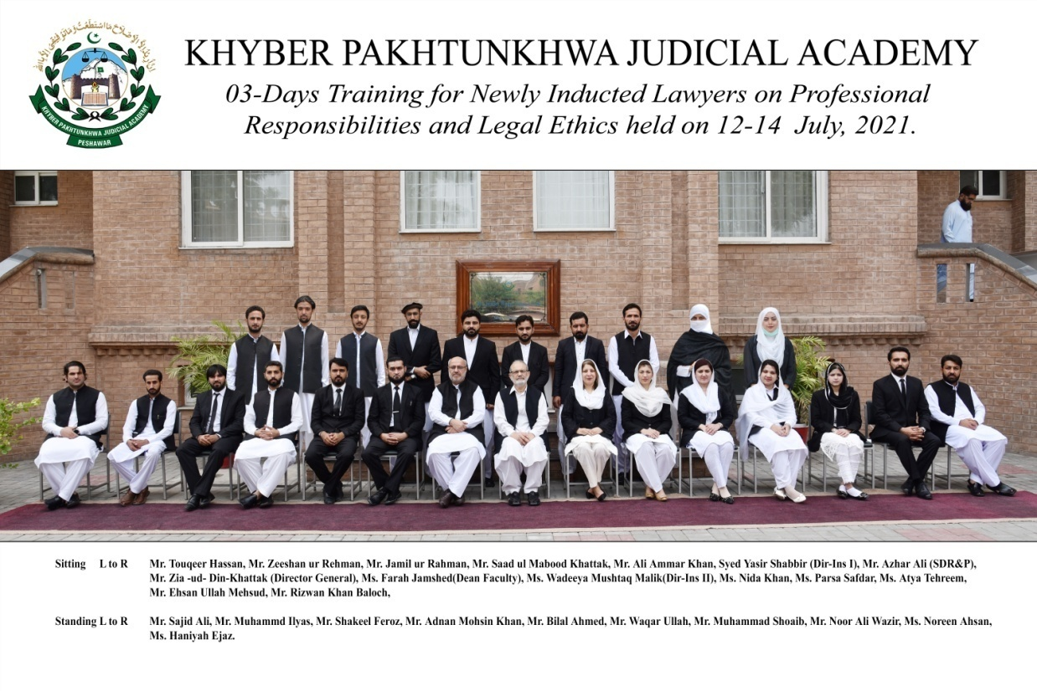

**Prepared by:**

Wadeeya Mushtaq Malik (Director Instruction-II)

**Finalized by:**

Ms.Farah Jamshed (Dean Faculty)  
______________________________________________________________________________Khyber Pakhtunkhwa Judicial Academy, Old Sessions Court Building, Jail Road, Peshawar

info@kpja.edu.pk | www.kpja.edu.pk

# 1.0 Introduction

1.1 The Khyber Pakhtunkhwa Judicial Academy (KPJA) is statutorily mandated to provide training to all justice sector stakeholders, to hold conferences, seminars, lectures, workshops and symposia in matters relating to court management, administration of justice, law and development of skills in legislative drafting and to establish liaison with research institutions, universities and other bodies including the Federal Judicial Academy, towards the cause of administration of justice. (Section 4 of the Academy Act)

1.2 Capacity building in every field of judicial activity is a *sine qua non* for streamlining the system in its entirety. With this end in view, KPJA arranged three-day training for newly inducted lawyers of Districts Dera Ismail Khan, Peshawar, South Waziristan, and Tank.

# 2.0 Purpose of the report

2.1 This report aims to assess the quality and impact of the training delivered from 12th to 14th July 2021.

2.2 The report begins with a general layout of the training session including, information about the participants, the resource person’s details, schedule of activities, proceedings, followed by recommendations for future improvements.

# 3.0 Participants

3.1 Participants of the training were newly inducted lawyers of Districts Dera Ismail Khan, Peshawar, South Waziristan and Tank, described as below:

| S.# | Name | District |
| --- | --- | --- |
|  | Mr. Ehasan Ullah Mahsud, Advocate | South Waziristan |
|  | Mr. Muhammad Shoaib, Advocate | South Waziristan |
|  | Mr. Noor Ali Khan Wazir, Advocate | South Waziristan |
|  | Mr. Toqeer Hassan, Advocate | Tank |
|  | Mr. Rizwan Khan Baloch, Advocate | Tank |
|  | Mr. Zeeshan-ur-Rehman, Advocate | Tank |
|  | Mr. Waqar Ullah, Advocate | Tank |
|  | Mr. Bilal Ahmad, Advocate | Tank |
|  | Mr. Jamil ur Rehman, Advocate | D.I Khan |
|  | Mr. Ali Ammar Khan, Advocate | D.I Khan |
|  | Ms. Parsa Safdar, Advocate | D.I Khan |
|  | Ms. Noreen Ahsan, Advocate | D.I Khan |
|  | Mr. Adnan Mohsin, Advocate | Peshawar |
|  | Ms. Atya Tehreem, Advocate | Peshawar |
|  | Ms. Haniya Ejaz, Advocate | Peshawar |
|  | Mr. Muhammad Ilyas, Advocate | Peshawar |
|  | Ms. Nida Khan, Advocate | Peshawar |
|  | Mr. Saad- ul-Mabood Khattak, Advocate | Peshawar |
|  | Mr. Sajid Ali | Peshawar |
|  | Mr. Shakeel Feroz | Peshawar |

# 4.0 Resource Persons

4.1 Ms. Farah Jamshed, Dean Faculty, Mr. Azhar Ali, Station Director/Senior Director Research & Publications, Mr. Syed Yasir Shabbir, Director Instruction-I, Ms. Wadeeya Mushtaq Malik, Director Instruction-II, Mr. Muhammad Farooq Research Officer, KPJA and Mr. Rehmanullah Shah ASC gave their insight on different subjects as per the Schedule of Activities detailed below:

|  |  |  |  |  |
| --- | --- | --- | --- | --- |
| Day – 1: Monday -12-07-2021 | | | | |
| S.# | **Activities** | | **Resource Person** | **Duration** |
|  | Registration & Pre-Evaluation  Recitation from the Holy Quran | |  | 08:30 – 8:45 |
|  | Welcome Address / Orientation | | **Director General** | 08:45 – 9:00 |
| 1.1 | **Professional Conduct**   * Duty to Court * Conduct with regard to Client * Conduct with regard to other Advocates * Conduct with regard to Public Generally | | Ms. Farah Jamshed, Dean Faculty, KPJA | 09:00-10:30 |
|  | Tea Break (10:30-11:00) | | | |
| 1.2 | **Administration of Justice**   * Criminal Trial with focus on mental illness including forensic health assessment. | | Mr. Azhar Ali, Senior Director Research & Publications, KPJA | 11:00-12:45 |
| Lunch Break 12:45 – 1:30 | | | | |
| 1.3 | **Law Search through Search Engines** | | Mr. Muhammad Farooq, Research Officer, KPJA | 01:30- 02:30 |
| Day – 2 : Tuesday - 13-07-2021 | | | | |
|  | Recitation from the Holy Quran | |  | 08:55 -09:00 |
| 2.1 | | **Professional Skills**   * **Legal Drafting** | Mr. Rehmanullah Shah ASC | 09:00 -10:30 |
| Tea Break (10:30 – 11:00) | | | | |
| 2.2 | | **Practical Exercise (Drafting of Pleadings)** | Mr. Rehmanullah Shah ASC | 11:00-12:30 |
| Lunch Break 12:45 – 1:30 | | | | |
| 2.3 | | **Production and Effect of Evidence**   * Burden of Proof * Examination of Witnesses | Ms. Wadeeya Mushtaq Malik, Director Instructions-II, KPJA | 01:30 -02:30 |
| Day – 3 : Wednesday - 14-07-2021 | | | | |
|  | Recitation from the Holy Quran | |  | 08:55 -09:00 |
| 3.1 | | **Mock Activity**  **(Examination of Witnesses)** | Faculty Members | 09:00 -10:30 |
| Tea Break (10:30 – 11:00) | | | | |
| 3.2 | | **Administration of Justice**   * Civil Trial / Civil Case Management | Mr.Syed Yasir Shabbir, Director Instructions-I, KPJA | 11:00-12:45 |
| Lunch Break 12:45 – 1:30 | | | | |
| 3.3 | | **Personal Opinion (One pager) / Feedback Session** | Faculty Members | 01:30 -02:30 |
|  | | **Concluding Ceremony**   * Class Representative Remarks * Concluding address of the Director General |  | 02:30 - Onwards |

# 5.0 Proceedings

5.1 Ms. Farah Jamshed, Dean Faculty, delivered the lecture on Professional Ethics & Conduct of Advocate with brief historical perspective in light of Legal Practitioner’s Bar Council Act 1965 and Legal Practitioners and Bar Council Act, 1973. Responsibilities of an advocate, in multifaceted legal arena in light of Chapter XII of LP&BC Rules were also highlighted. The speaker, through practical exercise sensitized the participants about vitality of upholding values in life and rationale behind them.

5.2 The session summed up by emphasizing the multifaceted role of advocate and their prime responsibility to uphold the Rule of Law.

5.3 Mr. Azhar Ali, Station Director/Senior Director Research & Publication, delivered the lecture on the Criminal Trial with special focus on mental illness including Forensic Health Assessment.

5.3 Mr. Syed Yasir Shabbir, Director Instructions-I, delivered the lecture on Administration of Justice with focus on Civil Case Management Rules. He gave brief overview of amendments in the Code of Civil Procedure, 1908 since, year 2018 till date. He explained insertion of Order IX-A through an amendment by Peshawar High Court on 23-01-2018 in form of Case Management and Scheduling Conference to address the issue of delay in adjudication.

5.4 Ms. Wadeeya Mushtaq Malik, Director Instructions-II, delivered lecture on the Production and Effect of Evidence. The speaker explained burden of proof in the light of Article 119-128 of Qanoon-e-Shahadat Order, 1984, Presumptions of Fact under Article 96-98 , Art.129 and Legal Presumptions under Article 90-95 of Qanoon-e-Shahadat Order, 1984. Manner of examination of witnesses under Article 130-161 of Ibid Order was also explained.

5.5 To improve research skills, Mr. Muhammad Farooq, Research officer gave practical demonstration to participants for law search through various search engines.

5.6 Mr. Rehmanullah Shah advocate delivered the lecture on professional skills. He emphasized the importance of legal drafting and highlighted common mistakes in legal drafting.

5.7 The Lectures of the resource persons Mr. Rehmanullah Shah and of Ms Wadeeya Mushtaq Malik were followed by practical activity with focus on drafting of pleadings and of miscellaneous civil/criminal applications. Thereafter, mock trial activity covering, stages of civil and criminal trial were conducted in supervision of Faculty members and resource persons. Four groups of participants were assigned task of scrutiny of pleadings and of criminal record ensuing, examination of witnesses, exhibition of documentary evidence following conclusion of trial. The practical exercise of participants were checked and marked as per group classification and shortcomings were discussed for improvement.

5.8 At the end of training session, participants were required to write one page personal opinion paper to signify views about training program upon nomination, learning experience at the session and outcome of training.

# 6.0 Impact of the training

6.1 Significant indicators of the training impact are:

6.1.1 Whether the training contributed to an improvement in the knowledge of the participants?

6.1.2 Whether the training will translate itself into practical utility?

The evaluation questionnaire was designed to deal with this aspect. The relevant feedback obtained from the participants is reflected below:

# 7.0 Quality of the training

7.1 As regards the quality of the training, it can be easily gleaned from the resource person’s evaluation by the participants. Moreover, the participants were asked to comment on the overall quality of the training program. Their response and the feedback, both on the assessment of the resource persons and the overall quality of the training program are shown in graphic form below:

7.2 Participants also furnished their general comments on the training. The same are reproduced verbatim:

1. Please add more mock activities and practical works.
2. Bring more practice in the training.
3. Very well and it’s conducted every within two months.
4. Practical learning and training should be given more importance. A short lecture on the art of advocacy should be introduced.
5. More practical activities should be added, the way of training was very informative and credit goes to worthy dean faculty and team.

# 8.0 Conclusion

8.1 Participants' graphic feedback indicates that the training's performance and effect have been rated very good.

8.2 Based on the participants' feedback, training modules can be further improved.

8.3 The trainees review reflects the achievement of training objectives.