REPORT
02-Day Training Course for District Attorneys
28 – 29 October, 2019
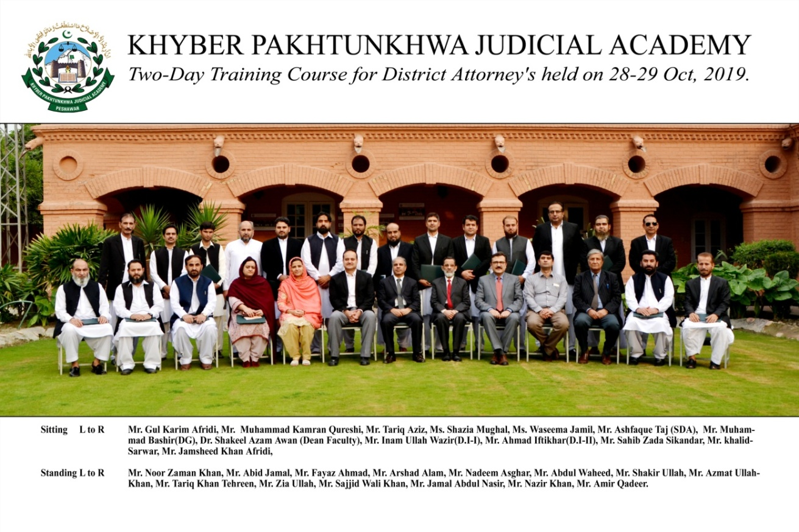
Prepared by:
Dr. Shakeel Azam Awan (Dean Faculty)
Ahmed Iftikhar (Director Instructions)
______________________________________________________________________________Khyber Pakhtunkhwa Judicial Academy, Old Sessions Court Building, Jail Road, Peshawar
info@kpja.edu.pk | www.kpja.edu.pk

1.0 Introduction

1.1 KPJA is statutorily mandated to provide training to all justice sector stakeholders, to hold conferences, seminars, lectures, workshops and symposia in matters relating to court management, administration of justice, law and development of skills in legislative drafting and to establish liaison with research institutions, universities and other bodies including the Federal Judicial Academy, towards the cause of administration of justice. (Section 4 of the Academy Act)
1.2 Capacity building in every field of judicial activity is a sine qua non for streamlining the system in its entirety. With this end in view, KPJA arranged two-day training for District Attorneys.

2.0 Purpose of the report

2.1 This report aims to assess the quality and impact of the training delivered between 28th and 29th October, 2019.
2.2 The report begins with a general layout of the training session including, information about the participants, contents of the lectures, the resource person details, followed by recommendations for future improvements.

3.0 Participants

3.1 Participants of the training were the District Attorneys. Table below, describes in detail, the names of participants.
S.No | Name | Designation
 | Mr. Tariq Aziz | District Attorney
 | Mr. Khalid Sarwar | District Attorney
 | Mr. Amir Qadar | District Attorney
 | Mr. Gul Karim Afridi | District Attorney
 | Mr. Jamshid Khan | District Attorney
 | Mr. Noor Zaman Khan | District Attorney
 | Mr. Jamal Abdul Nasir | Deputy District Attorney
 | Mr. Shakir Ullah | Deputy District Attorney
 | Ms. Shazia Mughal | Deputy District Attorney
 | Mr. Abdul Waheed | Deputy District Attorney
 | Mr. Mohammad Kamran Qureshi | Deputy District Attorney
 | Mr. Zia Ullah | Deputy District Attorney
 | Mr. Azmat Ullah Khan | Deputy Law Officer
 | Mr. Abid Jamal | Deputy Solicitor
 | Mr. Nazir Khan | Deputy District Attorney
 | Mr. Sajid Wali Khan | Deputy District Attorney
 | Mr. Arshad Alam | Deputy District Attorney
 | Mr. Fayaz Ahmad | Assistant District Attorney
 | Mr. Muhammad Tariq Khan Tareen | Assistant District Attorney
 | Mr. Muhammad Nadeem Asghar | Assistant District Attorney

4.0 Resource Persons

4.1 Sahibzada Sikandar, Advocate Supreme Court of Pakistan, Dr. Shakeel Azam Awan, Dean Faculty, KPJA, Mr. Ashfaq Taj, Senior Director Administration, KPJA, Mr. Inamullah Wazir, Director Instructions-I, KPJA, and Mr. Ahmed Iftikhar, Director Instructions, KPJA delivered lectures on different topics.
4.2 It would be necessary to make mention of each resource person along with topic dilated upon by him. The following table contains these details:-

SCHEDULE OF ACTIVITIES
Day – 1:Monday (28th Oct, 2019)
S.No | Activities | Resource Person | Duration
1.1 | Overview of Suits by or against Government: Emphasis on s. 80 CPC | Dr. Shakeel Azam Awan, (D&SJ), Dean Faculty, KPJA | 09:00-10:30
1.2 | Case Management Rules& Role of District Attorney | Mr. Ahmad Iftikhar,(AD&SJ), Director Instructions, KPJA | 11:00-12:30
1.3 | Arbitration Clauses: Scope & Significance | Mr. Ashfaque Taj, (D&SJ), Senior Director Admin, KPJA | 1:30-03:00
Day – 2 : Tuesday (29th Oct, 2019)
2.1 | Suits by or against Semi Government or Autonomous Bodies | Mr. Inamullah Wazir, (D&SJ),  Director Instructions, KPJA | 09:00 -10:30
2.2 | Effective Conduct of Government Litigation: Solicitors Perspective | Sahibzada Sikandar, Advocate High Court | 11:00 -12:30
2.3 | Role of District Attorney: Interactive Session | Faculty | 01:30 -03:00

5.0 Impact of the training

5.1 Significant indicators of the training impact are:
5.1.1 Whether the training contributed to an increase in the knowledge of the participants?
5.1.2 Whether that will translate itself into a practical utility?
The evaluation questionnaire was designed to deal with this aspect. And the relevant feedback obtained from the participants is reflected below:

6.0 Quality of the training

6.1 As regards the quality of the training, it can be easily gleaned from the resource person’s evaluation by the participants. Moreover, the participants were asked to comment on the overall quality of the training program. Their response and the feedback, both on the assessment of the resource persons and the overall quality of the training program are shown in graphic form below:

6.2 Participants also furnished their general comments on the training. The same are reproduced verbatim:
- We learned a lot from this training and it should be continued.
- Schedule of Activities should be share with the participants before attending the session.
- Such type of trainings should be held regularly in the future as well.
- This type of training should be arranged twice in year.
- Duration of the training may be increased.

7.0 Conclusion

7.1 Participants' graphic feedback indicates that the training's performance and effect have been rated good.
7.2 Based on the participants' feedback, training modules can be further improved.
7.3 According to trainees' reviews, it was the achievement of the objectives for which the training was designed and conducted.

