REPORT
One Week Training for Newly Appointed Additional District & Sessions Judges of Punjab
25-30 March, 2019
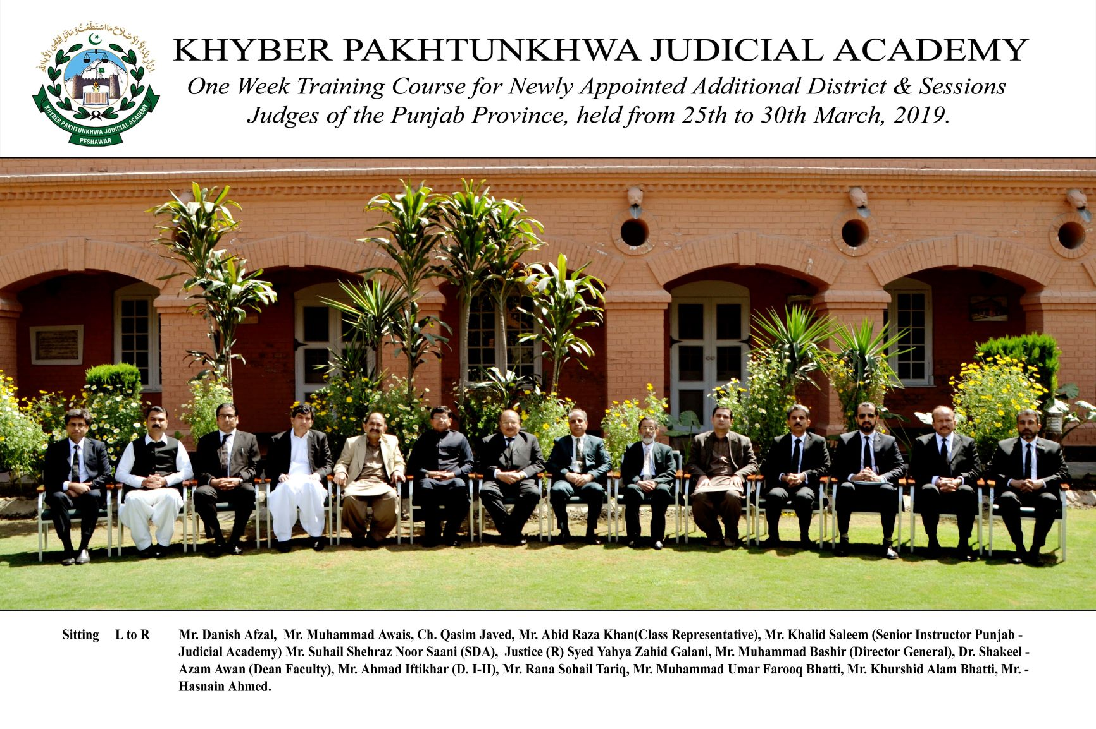
______________________________________________________________________________Khyber Pakhtunkhwa Judicial Academy, Old Sessions Court Building, Jail Road, Peshawar
info@kpja.edu.pk | www.kpja.edu.pk

1.0 Introduction

1.1 Khyber Pakhtunkhwa Judicial Academy is statutorily mandated to provide training to all justice sector stakeholders, to hold conferences, seminars, lectures, workshops and symposia in matters relating to court management, administration of justice, law and development of skills in legislative drafting and to establish liaison with research institutions, universities and other bodies including the Federal Judicial Academy, towards the cause of administration of justice.(Section 4 of the Academy Act)
1.2 Capacity building in every field of judicial activity is sine qua non for streamlining the system in its entirety. With this end in view, the Judicial Academy with the understanding, assistance and as a part of mutual understanding with Punjab Judicial Academy, arranged one week training for newly appointed Additional District and Sessions Judges from Punjab.

2.0 Purpose of the report

2.1 This report aims at looking up the quality and impact of the training delivered between 25th and 30th March, followed by recommendations for future improvements.

2.2 The report begins with general layout of the training sessions including information about the participants, contents of the lectures and the details as to resource persons.

3.0 Participants

3.1 Participants of the training were the newly appointed Additional District and Sessions Judges from Punjab. Table below mentions the names of participants.
S.No | Name
 | Mr. Muhammad Awais, AD&SJ
 | Mr. Muhammad Umar Farooq Bhatti, AD&SJ
 | Mr. Khurshid Alam Bhatti, AD&SJ
 | Mr. Abid Raza Khan, AD&SJ
 | Ch. Qasim Javed, AD&SJ
 | Mr. Hasnain Ahmed, AD&SJ
 | Mr. Danish Afzal, AD&SJ
 | Mr. Rana Sohail Tariq, AD& SJ

4.0 Resource Persons

4.1 Former Justices Syed Yahya Zahid Gilani, Mr. Abdul Latif Khan, Mr. Riaz Ahmed and former Chief Secretary Mr. Abdullah honored the occasion and shared their knowledge and experience with the participants. Besides, Director-General, Dean Faculty of the Academy, Director Regulation of Peshawar High Court and PSO to Honorable, the Chief Justice. Peshawar High Court, Peshawar and Director Instructions, Judicial Academy gave their insight on different subjects.
4.2 It would be necessary to make mention of each resource person along with topic dilated upon by him. The following table contains these details:-
Day 01 - Monday 25-03-2019
# | Topic | Resource Person
01 | Self, Stress & Time Management - I | Mr.Abdullah,  Former Chief, Secretary
02 | Self, Stress & Time Management - II | Mr. Abdullah,  Former Chief Secretary
03 | Precedents | Director Instructions, KPJA (AD&SJ)
Day 02 - Tuesday 26-03-2019
 | Topic | Resource Person
04 | Case Management- Civil -I | Mr. Zia-ur-Rehman, (AD&SJ)  Director Regulations, PHC
05 | Case Management- Civil -II | Mr. Zia-ur-Rehman, (AD&SJ)  Director Regulations, PHC
06 | Order Sheet writing - Civil | Mr. Muhammad Bashir, (D&SJ)  DG KPJA
Day 03 - Wednesday 27-03-2019
 | Topic | Resource Person
07 | Criminal Appeals and Revisions | Dean Faculty KPJA (D&SJ)
08 | Alternative Dispute Resolution | Barrister Faisal Khan  Advocate Supreme Court
09 | Order Sheet Writing - Criminal | Mr. Muhammad Bashir, (D&SJ)  DG KPJA
Day 04 - Thursday 28-03-2019
 | Topic | Resource Person
10 | Judgment Writing - Criminal | Mr. Muhammad Zeb Khan (D&SJ)  PSO to HCJ
11 | Judicial Conduct and Ethical Issues | Mr. Riaz Ahmad  Former Justice IHC
12 | Overview of Land Acquisition Act | Mr. Abdul Latif Khan,  Former Justice PHC
Day 05 - Friday 29-03-2019
 | Topic | Resource Person
13 | Rights of Child under the Constitution | Barrister Ummar Zia-ud-Din
14 | Bonded Labour / Domestic Violence | Mr. Umar Gilani, Advocate High Court
Day 06- Saturday 30-03-2019
 | Topic | Resource Person
15 | Judgment writing -Civil | Mr Abdul Matin Khan (D&SJ Retired) Director FJA
16 | Court Management (Interactive) | Syed Yahya Zahid Gilani  Former Justice PHC

5.0 Impact of the training

5.1 Significant indicators of the training impact are:
5.1.1 Whether the training contributed to any increase in the knowledge of the participants?
5.1.2 Whether that will translate itself into a practical utility?
Evaluation questionnaire was designed to deal with this aspect. And the relevant feedback obtained from the participants is reflected below:

6.0 Quality of the training

6.1 As regards the quality of the training, it is easily gleanable from each resource person’s evaluation by the participants. The participants were, nevertheless, also asked to comment upon overall quality of training program. Graphic feedback received from the participants, both on each resource person's evaluation and overall quality of the training program is shown below:

6.2 Participants also furnished their general comments on the training. The same are reproduced verbatim:
- Though being efficiently designed, however, perhaps adding some practical exercises, e.g., mock trials and workshops on syndicate analogy would further add to the value of the training program. That would be my suggestion, said Mr. Abid Raza Khan, AD&SJ, Lahore.
- Academy should also send Judicial Officers from Khyber Pakhtunkhwa to Punjab Judicial Academy, Lahore for short courses to have cross -experiences and interaction
- Keep it up

7.0 Conclusion

7.1 The end result seems to be welcoming. It was successful achievement of the objectives for which the training was designed and conducted.
7.2 Graphic feedback of the participants would evidence that quality and impact of the training were rated high.
7.3 Khyber Pakhtunkhwa Judicial Academy and Punjab Judicial Academy may further collaborate on exchange of trainees and trainers for uplift of the academies in general and capacity building of stakeholders of justice sector especially Judicial Officers in particular.
7.4 Increase in time span of the training will help add to the utility of the training.
7.5 It would be rather better to get TNA before conducting such trainings in future and to develop a training module by mutual collaboration of the two academies.

